CHAPTER 14B - CANOE TRIP DOWN THE CALEDON AND ORANGE RIVER - DECEMBER 1960

During 1959 I built a rowing boat in the school workshop and I had then tried to row this down part of the Caledon River. I soon discovered that a rowing boat was most unsuitable for such a venture as you had your back to the direction of travel down the river. Consequently, you were unable to cope with rapids, possible sand banks or rough fast flowing water. I decided to abandon my week-long trip after a few days and was able to persuade a kind farmer to transport me and the boat to the nearest railway station. I managed to sell the rowing boat at auction for a reasonable price before we set sail to the UK.

I then decided to design and build a marine ply canoe in the school woodwork department. I was joined by my two friends Graham Witford and Martin Weighell who also built canoes using my design. The canoe was broader than most designs and had a fairly flat bottom. I felt this would enable the craft to be more stable and also cope with shallow water and sandbanks. The woodwork teacher was a great help and encouragement and was able to recommend several changes to the design. We included a mechanism that would take a crude sail. My canoe also contained a small water tank with a tap so that we could take on fresh water.

We started to plan a more ambitious trip down part of the Caledon River which eventually joined the Orange River. We had very much hoped to be able to undertake the 700 miles to Upington during the forthcoming summer holidays.

The Headmaster Mr Spencer Chapman also gave us a huge amount of encouragement. He wrote to the manager of the South African Sunday Times asking if they would sponsor the venture and he decided to give us £90. However, he requested that we sent the newspaper weekly reports of our progress so that these could be included in the paper. We had to send these by express post from Post Offices en route. He arranged for a photographer to take a picture of us by my canoe outside the workshop.

Fortunately, I was able to keep the notes that Martin and I wrote about our adventures soon after we arrived home. My father typed up these notes which has enabled me to write a fairly accurate description of what occurred.

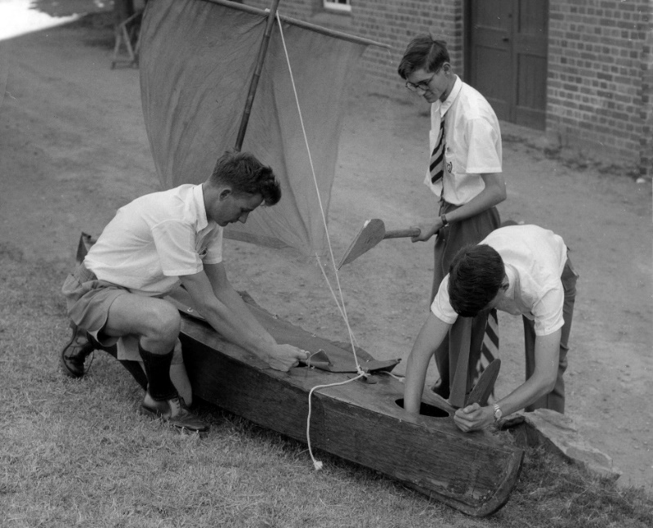
Me with Martin and Graham with my completed canoe 1960

The first Sunday Times article appeared about a week after the above photograph was taken. I have not been able to scan this article as the copy I have has long since disintegrated. However, I have typed out what it contained below.

Their flimsy river craft. Three boys set out to canoe Orange River
SUNDAY TIMES REPORTER

“Three adventurous schoolboys will spend Christmas Day canoeing down the Caledon and Orange River. If they can, they hope to celebrate the day with roast duck.

The boys – Paul Hebblethwaite 18, Martin Weighell, 18, and Graham Witford, 15 – are pupils at St Andrew’s College, Grahamstown. They left Wepener, in the Free State, at six o’clock this morning on the first lap of their 760-mile journey down the Caledon and Orange River to Upington.

“We are determined to get there even if we have to walk,” said Martin, shortly before they left Grahamstown.

Explorers
Why are they going on this expedition? “Mainly for adventure,” was Martin’s reply. “It is a way of spending our Christmas holidays and we also hope to improve our Geography.”

All of them are members of the school’s Exploration Society. Travelling 10 hours per day, they hope to reach Upington within a month. They may then hitchhike to the Augrabies Falls, 60 miles further on.

Built boats
The boys designed and built their canoes in the school carpentry shop. The boats are 9ft 6inches long and 2ft 6 inches across, and have flat bottoms to make the jumping of rapids easier.

The boys have been spending weeks collecting equipment and information for their expedition. They have a primus stove, wood-chopper, radio for weather reports, and detailed maps of their route. A Grahamstown Chemist has lent them a complete first-aid kit.

Paul is taking 154 dentist injection tubes with him which he hopes to fill with samples of soil and water. Martin, an amateur geologist, wants to collect as many rocks and stones as his canoe can carry.

Between them they have £4 10s and a post office savings book.

Paul and Graham have been on canoe or rowing boat trips before with two other St Andrew’s boys. Paul last year rowed a boat he built from Teyateyaneng, in Basutoland, to Wepener, 176 miles away. Graham has also taken a canoe up the Bushman’s River.”

Before I give details of our trip, I give some statistical details relating to the Caledon and Orange Rivers. The Caledon River is called the Mohokare River in Lesotho is a major river located in central South Africa. It has a total length of 399 miles (642 km) and rises in the Drakensberg Mountains on the Lesotho border with South Africa and flows south-westward and then westward before joining the Orange River near Bethulie in the southern Free State.

The Orange River has several names including Gariep River, Groote River and Sengu River. It rises in the Drakensberg mountains in Lesotho at an altitude around 3000 m and flows west to the Atlantic Ocean. It is one of the longest rivers in the continent and one of the longest south of the Tropic of Capricorn. It is also the longest river in South Africa with a total length of 1,367 miles (2,200 Km). While in Lesotho it is called Sengu River and parts of it freeze during cold winters because of the altitude. The total catchment of the Orange River (including the Vaal) extends over 973,000 square kilometres, therefore, about 77 percent of the land area of South Africa. Approximately 366,000 square kilometres (38 percent) is situated in Lesotho, Botswana, and Namibia. The map below shows the Orange River Basin. The second map gives more details of all the rivers with sources mostly in Lesotho all of which feed into the Orange River. It also gives the location of the Caledon River.

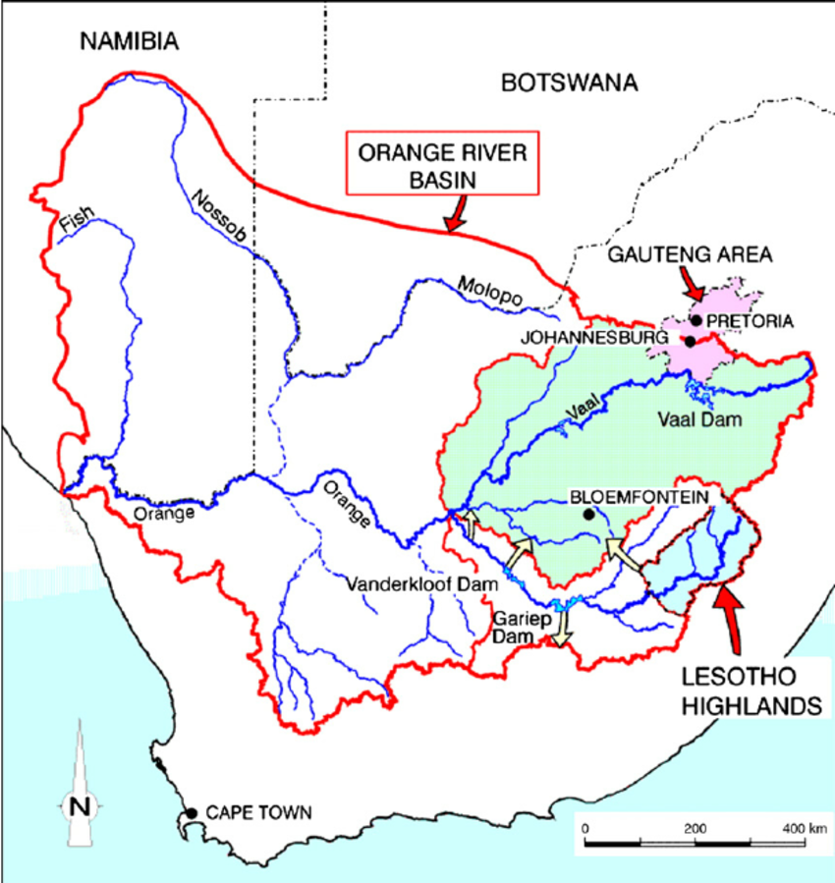

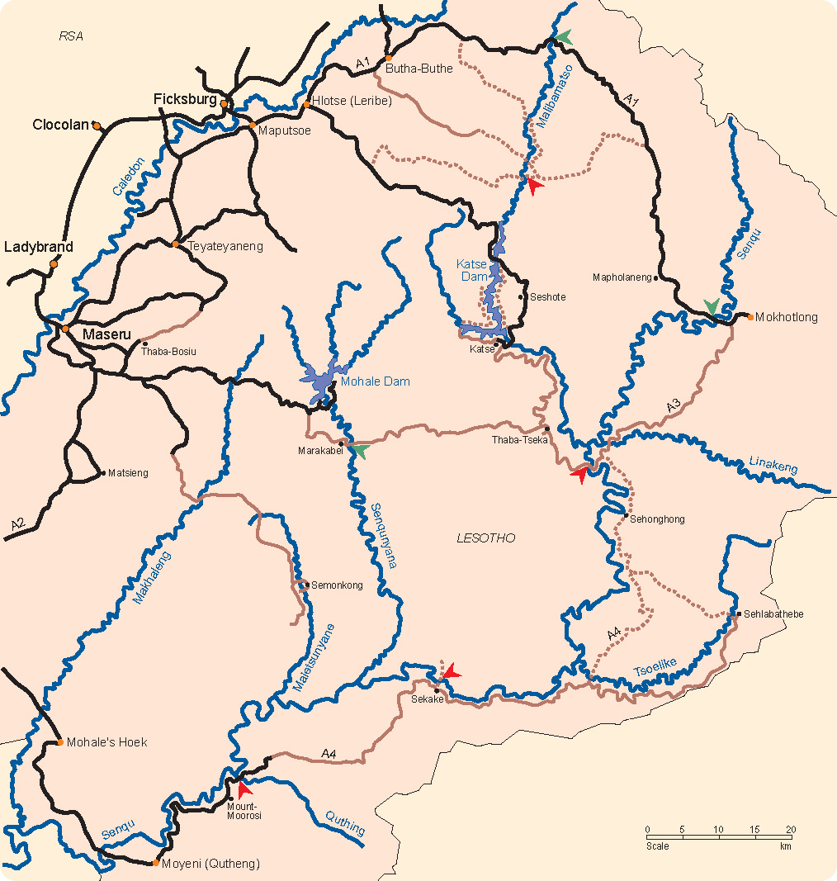

Our adventure started at Grahamstown station on the 9th December 1960. We loaded our canoes into the goods section of the South African Railways (SAR) train which stopped at Jammerdrift station near Wepener where we would start our trip in the Caledon River. The guard was reluctant to have them on the train as he maintained that they could be easily damaged. But we somehow managed to persuade him to do so on the understanding that we were prepared to take the risk – what else could we do?

We arrived at Jammerdrift at 1.45pm around 1 mile from the river. We helped to unload our canoes. Fortunately, there was a lorry belonging to a flour mill company outside the station and the driver kindly transported our canoes to the river bank. The canoes were offloaded by a couple of Africans and they helped us to get them and our possessions down to the river. At around 4.30pm we set off on our journey. We felt ambitious, excited and full of energy at this stage. The first thing we noticed was that the Caledon was running very low and there were sandbanks in all directions. After paddling for about 200 yards, I found that my canoe was taking on water. On examination I was able to find a small hole which must have been caused in transit with SAR. I was able to repair the hole using a small piece of ply and using the appropriate fast setting glue. We then paddled on for around 10 miles and decided to set up camp for the night. I managed to cook scrambled eggs and sausages for our meal on the primus stove. During the night we all suffered from the effects of drinking the river water even though we had boiled it. We had not been able to fill my water tank with fresh water at this stage.

On Saturday the 10th we rose at 5 am and after a hasty breakfast of porridge we set off once again. We made slow progress avoiding sandbanks. In the afternoon we were caught by a heavy storm but we battled on for around 15 miles even though we were drenched and cold. After emptying the canoes of all water accumulated from the storm, we were able to walk to a nearby farm. The farmer Oom Piet Hugo, his wife and his two beautiful daughters invited us to stay the night. They lent us some dry clothes and we returned to the river and make sure the canoes were safe. The daughters dried our clothes and then provided us with a very enjoyable supper. We managed to converse with them in Afrikaans but at times they switched to English. We were made very comfortable in their spare room.

The next day (Sunday 11th) we were woken by Oom Piet at 5. After a good breakfast Oom Piet gave us plums, milk, eggs, biltong, raisins and helped us patch Martin’s canoe that had a persistent leak with reservoir cement. The whole family then waved us off. He then contacted another farmer called Oom Hendrik Vander Walt further down river who was waiting for us and provided us with some lovely large peaches. We paddled on and met with our first disaster. While Martin’s canoe was being pushed through powerful rapids it became wedged against a rock and turned on its side. Torrents of water swept clothes, primus stove, coffee, rucksack, pot, pan and colour films into the river. After a desperate struggle the canoe was released by turning it over to get rid of all the water. Fortunately, we were able to retrieve the primus stove and pots and pans. Thoroughly fed up, we sat on the bank and consumed a can of bully beef for lunch. We then paddled on hoping to make up some time. Late in the afternoon we were again caught in a violent storm and were soaked to the skin. Fortunately, a kind farmer called Oom Grayling (he had been contacted on the farmers network) put us up for the night. His wife dried out our clothes and provided us with a meal.

On Monday the 12th we rose at 5am and after a good breakfast provided by Grayling’s wife, we set off at around 6am. After around 5 miles we came across our first weir which was around 15 ft high. We were forced to carry the canoes round this obstruction which was exhausting. We paddled on through more rapids and Martin again capsized and lost his watch and his camera was wrecked. However, we manged to cover around 30 miles in the extreme heat and by 7pm we were badly sunburnt (no sun tan cream in the 1960’s) and set up our camp at 6.30pm. After cooking a meal on an open fire, we felt so exhausted we were in bed by 8.30pm.

The next day (13th) we were up by 6.30am and after breakfast at around 7.30am we set off and made good progress at around 3 miles per hour as there were no rapids but occasional headwinds. By the time we set up our camp at 6.30pm we were all exhausted as it was exceptionally hot. However, we covered about 40 miles and felt encouraged by our progress.

On the 14th we arose at 6am after a terrible night and a scanty breakfast. We set off at around 8pm. At 10am we reached Commissie bridge and I hitched a lift to Smithfield to obtain supplies and write a letter to the Sunday Times in relation to our progress thus far. I had an awful lunch in a café and then had to wait another hour for the post office to open. I then sent telegrams to our parents and to the Sunday Times and posted the letter I had written. I had then to walk 3 miles before getting a lift back to the river. On my return I found Graham and Martin asleep on the river bank. Martin had managed to purchase some eggs from a very grumpy farmer’s wife. We again set off at 4.30pm and continued down river until 6.30pm. We walked to a nearby farm and the farmer allowed us to sleep overnight in a dilapidated rondavel. He also gave us a plate of pap and eggs for super. We turned in at 8pm and all slept well.

On the 15th we arose at 5.30am and had breakfast by the river. We were able to obtain three bottles of milk and a bucket of fresh water to top up my water tank from the farmer. Before we left at 7.45am we spent some time tarring Martin’s boat to try and stop more leaks. We soon encountered the worst rapids of the whole trip. We struggled for hours and had to carry the craft around 3 waterfalls. At one stage we had to carry our canoes for around a mile and a half. By 5pm we were exhausted and decided to call it a day but after spotting a farm house about 2 miles ahead we battled on in the hope that a kind farmer would take us in for the night. Unfortunately, we did not spot a 15 ft waterfall ahead. We managed to land on a rock and bring the canoes to safety. Graham and I managed to let our canoes down the drop safely but Martin slipped and fell heavily on his back. His canoe crashed over rocks but fortunately came to rest a few inches from the drop. With a struggle he was then able to lower his canoe successfully. Before we reached the farm house we had to battle through another mile of rapids. The farmer, Oom Piet Schoeman kindly allowed to sleep in his barn and provided us with some food. He informed us that there were some very serious rapids ahead which went on for around 5 miles and suggested that he should transport our canoes around them. We readily agreed.

On the 16th we had a scanty breakfast of pap. Oom Piet Schoeman helped us to load our canoes on his truck and transported us and the canoes round the serious rapids. We drove to Bethulie on a terrible bumpy road for around 45 minutes with Martin and me on the back of the truck. We kept bouncing into the air when he went over a deep rut in the road. On reaching the river at about 9.30am we unloaded and Oom Piet then took us back to Bethulie and had something to eat and drink in a café. He then returned us to the river and after a hearty farewell from Oom Piet we set off at 11.30am. We paddled on rapidly and after an hour reached the confluence of the Caledon with the Orange River at Bethulie. We felt excited having reached the main river. We had a good meal in the same cafe in Bethulie. We returned to the river and battled against a force 6 headwind. During the whole day the heat was intense at around 95⁰ F or 35⁰ C. We eventually came across a farmhouse and the farmer and his wife kindly gave us supper and put us up for the night.

On the 17th December we got up and had coffee and breakfast and were on the river at 7am. We made good progress until another strong headwind started at around 11.30am which enhanced the effects of the intense heat. We then made slow progress but battled on until lunch time. Over lunch we tried to get one of the cameras that was damaged by being submerged to work but sadly it was damaged beyond repair. As a result, we were never able to take any photographs of our trip. After lunch due to the headwind we were only able to cover about half a mile in an hour until around 3.30pm when the wind was behind us due to the direction of the river. However, at 4.30pm we were again paddling against the wind that was so strong that it produced large waves. After around an hour we only managed to progress around half a mile and were exhausted. At around 7.30pm we dragged the canoes to a safe place and set off to try and find a farm. We walked along the bank and inland but were unable to locate a farm and, on our way back we got lost in the dark. Fortunately, we came across an old abandoned house and thankfully, settled there for the night. One of Martin’s feet was so badly sunburnt that he was unable to remove his sock.

On the 18th we rose at 5.30am walked back to the river and had breakfast and set off at 7.30am. With a slight wind behind us we made reasonable progress. At 10.30am we came across some difficult rapids but managed to navigate through them without mishaps. We continued on with the wind behind us. It was extremely hot at 101⁰ F or 38⁰ C registering on my thermometer. At 12.30pm we managed to purchase some milk at a farmhouse and also get some water to top up my tank. After lunch we again came across terrible rapids and Martin’s canoe was smashed on rocks and capsized and his foot was badly bruised by the weight of the canoe on his foot. He lost most of his equipment as well. What made it worse was that Martin also damaged my paddle by trying to push away from a rock. I had lent him my paddle as it was curved at the ends and was easier to use and more efficient. We struggled on for around another hour until we came across a farmhouse where the farmer helped us to try and repair his canoe using pitch. They invited us to stay and his sons took us around the farm and showed us their 3-story pump house which was used to pumped water from the river to irrigate their crops. I found al this most interesting as I already was thinking about a career in agriculture. As it was a Sunday, we had a church supper in the Dutch style. In the evening we were able to fix my paddle with glue. We turned in at 8.30pm as we were exhausted.

On Monday the 19th we got up at 6am and were back on the river at 8.30am. We made good progress for 10 miles and then were again caught in a storm and got drenched. Martin’s canoe kept taking on water due to the damage and he reluctantly decided to abandon the rest of the trip and return home by train. Fortunately, we were able to leave our canoes on the bank and walk back to the farm where we stayed the previous night. One of the farmer’s sons loaded Martin’s canoe onto their Lucerne lorry and kindly took him to Donkerpoort which was the nearest station where he was able to catch a train back to Grahamstown. We had mixed feelings about his departure as we had enjoyed his sense of humour and his contributions keeping a log of our progress. However, he was struggling and at times he could not keep up and was left far behind which delayed our progress. We then stayed another night with the farmer and his family.

On the 20th we rose at 4.39am had coffee and walked back to our canoes. After bailing out the water we set off at 7am and covered about 5 miles and then stopped and had breakfast. We then battled on against the head winds and many dangerous rapids. On one occasion Graham was completely submerged shooting a rapid but came up eventually the right way up much to his amusement. I started to suffer with a lot of back pain which made me wonder whether I could continue. We arrived at Norval’s Pont at 11.30am feeling a little fed up, tired and hungry. This adventure was turning out more difficult than we had anticipated. We telegraphed our anxious parents at the post office in Norval’s Pont and then bought more supplies. A local farmer, Mr Holland, gave us lunch and a bed for the night. His wife kindly repaired my torn cockpit canvas.

On the 21st we got up at 4.30am and had breakfast but unfortunately Graham was so sick that he could not continue, so Mr Holland’s son Tom accompanied me as far as Colesberg Bridge around 20 miles on in Graham’s canoe. Tom brought his gun and was able to shoot a couple of ducks and some dassies. At 10.30am we came across a waterfall and had to carry the canoes round it. We were also paddling into headwinds which slowed our progress. At 11.30 we met another waterfall just before entering a gorge and were forced to carry the canoes around it. We eventually arrived at Colesberg Bridge where Mr Holland and Graham (much recovered) met up with us. After hearty farewells to the Hollands, we continued our journey. From there Graham and I came across 2 large waterfalls which we had to carry round. Later in the day headwinds raged and we averaged about half a mile per hour. Mr Holland had contacted the next farmer called Mr Venter and eventually we arrived and his family kindly put us up for the night and provided us with a good evening meal. It amazed both of us how kind and hospitable all these farmers and their families were. Nothing seemed too much trouble for them.

On the 22nd we were up at 5.30am and back on the water at 6.15am. We made good progress and stopped at 7.15am to have breakfast. We then left at 8am and passed through a 12-mile gorge with steep rocky sides. We did not have to do much paddling as the rapid flowing river enabled us to move at an astonishing speed. However, we did struggle with extremely powerful whirlpools which on occasions turned us right round. As the river was forced through this narrow gorge, we estimated that we were moving at about 12 miles per hour. We met numerous rapids and waves and had to bail out our canoes every time we jumped the more serious ones. We were able to spot some lovely spring buck which were owned by a local farmer and he was on the bank to wave us in. Obviously, another of Mr Holland contacts. The family provided us with a good lunch and showed great interest in our adventure. We left the farm at 2.30pm and again battled through rapids and this resulted in us having to carry the canoes for around 50 yards to get round the worst ones. We came across two other canoeists in their fibre glass canoes and we all set up camp together at 5.30pm. They were brothers called Van Riet. We enjoyed a meal together before we all went to bed at around 8pm as we all planned to make a very early start. The Van Riet’s were amazed that we had built our own canoes but they felt that marine ply canoes were not really suitable for the rapids as they were likely to be easily damaged and of course they were quite right. Their canoes were also very light and they were able to empty the contents then carry them on their shoulders and then return for their kit and supplies.

On Friday the 23rd December we were all up at 5.30am and on the river at 6.15am. We stopped for breakfast but the Van Riet’s continued their journey after we had exchanged addresses. After a hasty breakfast we continued and came across numerous rapids but the canoes fared well even though we took on a lot of water and had to frequently stop and bail out. We reached Havengaburg Bridge at about 5.30pm after covering 48 miles which was our record daily distance. We stayed the night with a very wealthy farmer (another Mr Holland contact) and his beautiful 16-year-old daughter with long blonde hair. I have always been attracted to blonds! We were not sure where his wife was but did not think it was right to ask.

On Saturday the 24th we were up at 5am and given sandwiches for breakfast and a large packet of peaches. We stopped briefly for breakfast at 7am after rapidly covering 7 miles as there were no rapids. We were soon back on the river and at around 10.30am we reached what we thought was a serious stretch of rapids. We were able to beach our canoes some distance away and walk along the back intending to survey the rapids. Unfortunately, a large tree blocked our way and we were not able to do so. We were too tired to bother trying to break through the branches and returned assuming the rapids were navigable. Graham set off first with me close behind. Suddenly we came across a waterfall of around 10 feet ahead of us. The current was so strong that we had no option but to go over it. We both capsized at the bottom of the fall. Graham was caught under his canoe and had to push himself out only to be sucked under by the drop wave. I was thrown out while the canoe turned over and also sucked under by the drop wave. When I came up, I was hit by another large wave and again submerged. Graham managed to grab his overturned canoe. While I was underwater, I manage to grab the rope attached to my canoe. I pulled myself to the craft. Graham managed to get to land but me and my canoe plus paddle were washed downstream. Graham ran along the bank in pursuit. When he had caught up with me, he took a headlong plunge into the river and helped me bring my canoe to safety about 250 yards downstream from the waterfall.

Fortunately, losses were small but we lost our snake bite serum, a mug, plate and pot lid. We were later informed that the waterfall was actually 12 feet high. By 11.30am the canoes were completely bailed out and at 12pm we had lunch and then had a 2-hour sleep as it was very hot and we also needed to dry out our clothes. We then walked to a farm to see if we could get some dry matches and Mr Bluemen the farmer kindly asked us if we would like to stay with him and his family for Christmas and we gratefully, accepted his offer. We then returned to the river to make our canoes safe and collected our wet clothes etc. While we were there Van Riet arrived and informed us that his brother’s canoe had been lost at the waterfall and he was going on by himself. It made us feel lucky that we still had our canoes intact and functional.

On the 25th we had a wonderful Christmas with Mr Bluemen, his wife and two children. His farm was in an exceptionally dry area and they had not had any rain for over 4 years. We witnessed his African cowman drink 3 mugs of vodka, 2 mugs of wine, 1 mug of brandy and 2 mugs of peppermint liquor then walk home and at 6pm arrive back to milk the cows! On Christmas day we were served a wonderful roast chicken dinner by his wife which was mostly cooked by their African cook.

On Monday the 26th we left at 6.30am and paddled for 2 hours and stopped for breakfast. Van Riet came by and stopped for breakfast with us. We were back on the river by 9.30am and at around 2.30pm my canoe was turned over in a whirlpool and I lost my school ruck-sack, my hat and one of my shoes. We were both feeling very fed up and decided that we would try and continue on to reach Prieska in the Kalahari Desert and then call it a day. We made good progress for the next few hours and reached Orange River Bridge at 3.30pm. We walked around 2 miles along the railway track jumping from one sleeper to the next as the ground was so hot. The temperature was about 105⁰ F or 41⁰ C. We waited the rest of the day at Orange River Station for the shop keeper to open his shop so that we could purchase hats and shoes. Apparently, he and his family had gone off for a picnic. He eventually turned up and we were able to purchase caps and shoes. Unfortunately, he did not have hats so the caps were the only option even though they looked awful and we looked decidedly funny wearing them. Below is a photograph of us wearing the caps which my father took when we arrived home. The shop keeper (Mr Van Rensburg) was fascinated hearing about our adventure thus far and he and his wife asked us if we would like to stay the night and tell them more about it and we readily agreed. The kindness and hospitality of strangers was the major reason we were able to get thus far. Everyone we met were so kind.

On Tuesday the 27th we were up at 5am and Mr Van Rensburg drove us to the river and waved us farewell. He had also supplied us with various items of food without charge. Unfortunately, I have no records of the journey to Prieska on the river as my logbook did not contain anything. Sadly, I am unable to remember why. Possibly, I had decided that I had enough of logging our journey or possibly Graham had taken over and then never let me have his notes. I may have even lost these notes or they were destroyed by getting wet.

We arrived in Prieska via Hopetown on the 2nd January 1961.The town lay on the south bank of the river in the Northern Cape. I vaguely remember us spending New Year’s Day on a farm some miles from Prieska with an English farmer. In Prieska we were able to spend the night with another storekeeper and he kindly agreed to rail our canoes back to Grahamstown which was exceptionally helpful. He also collected the canoes from the river in his truck. We were able to draw some money from the post office to pay him for the cost. We had by then realised that it would be impossible to get all the way to Upington on the river. We were rapidly running out of money and finding it difficult to keep going. We had covered about 450 miles and we felt that was quite an achievement. We therefore decided to hitch a lift to Upington so that we could eventually visit the famous Augrabies Falls.
Augrabies Falls are the major waterfall of the Orange River. The falls are commonly cited as being 480 feet tall, but this appears to be a figure quoting the change in elevation from the top to the bottom of the canyon. The main part of the falls in actuality stands about 183 feet tall. In full flood, the Orange River fills the canyon below the falls and in many places almost 500 feet deep - nearly to the brink, and in truly epic events, the falls themselves can be almost submerged. It has been estimated that 95% of the flow of the Orange River goes over the falls in low water. During floods around 80% goes over the falls. The remaining water forms 19 minor falls, most of which exceed the main fall in height. The name Augrabies comes from Aukoerebies, a Khoi name meaning, the place of the great noise.
The falls are certainly among the major large-river waterfalls in the world, so notable in fact that Edward Rashleigh wrote extensively of the falls in his 1935 book Among the Waterfalls of the World. However, despite the factors making this such a great waterfall, because the volume of the Orange River varies so greatly between the wet season and the rest of the year, and ultimately because it’s so hard to appreciate the falls from the ground, Augrabies Falls can't be considered more than a second-tier world class waterfall.

I have included some statistics in relation to these falls below.

Total height 183ft or 56m
Tallest drop 183ft or 56m
Number of drops 1
Average width 80ft or 24m
Maximum width 2,300ft or 701m
Pitch 75 degrees
Run 200ft or 61m
Form Sliding punchbowl
Watershed Orange River
Average high volume 11,050 cfs or 313 cms
Average low volume 0 cfs or 0 cms
Source Lesotho South Africa border in Drakensberg mountains

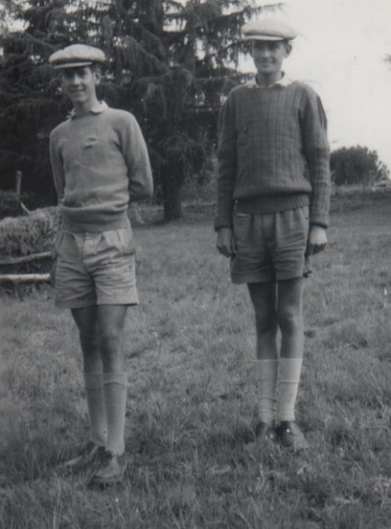
Graham Whitford and I wearing our terrible flat caps in 1960

On the 3rd January 1961 we started walking from Prieska along the road to Upington carrying around 40 lbs on our backs hoping to hitch a lift. We walked about 15 miles in blazing sun before we were able to thumb a lift on the back of a lorry all the way to Upington. We arrived in Upington at 7pm and located Mr Holmes a local garage owner who was an Old Adriane. He had been contacted by our headmaster Spencer Chapman who had asked him to look after us if we turned up in Upington. The family provided us with a good meal and then dropped us off at the best hotel in the town where we were able to have a bath and spend a comfortable night in a bed. He even paid the bill in advance! The kindness of strangers never seizes to amaze me. We must have looked quite a site in our shabby and rather dirty clothes and I had grown quite a sizeable beard.

Upington was founded in 1873 and is located in the Northern Cape province and lies on the banks of the Orange River in the Kalahari Desert. It is the principal town and commercial, educational and social centre of the green Kalahari due to its agriculture which exist due to irrigation from the Orange River. However, its economy owes a lot of its prosperity to tourism due to the flowers of Namaqualand and the Augrabies National Park.

On the 4th January we were up and breakfasted by 8am and then went to the post office to send telegrams to our parents and a letter to the Sunday Times. We then called in at Holmes Garage and Mr Holmes very kindly loaned us a real vintage model Chevrolet so that we could drive to the Augrabies Falls. His mechanic warned us that the radiator was leaking slightly and he provided us with a large can of water so that we could top it up when needed. He also warned us that the river was in spate and we should be careful when viewing the falls.

Unfortunately, after around 15 miles we realised that the Chevrolet’s radiator was boiling. We topped it up and then had to repeat every 3 miles in order to stop it boiling. We were rapidly running out of water and had to stop at windmills to top up our water supply. The ground was red and very dry with scrub bushes scattered about. Stones of intense colour and beauty could be seen everywhere. Eventually, we arrived in Keimeos, about 27 miles from Upington, and the garage mechanic there advised us to return to Upington as he was unable to repair the radiator. He topped up our can of water to help us on our return journey. Consequently, we were never able to see the falls which was a huge disappointment.

We then decided to take his advice and set off back to Upington. We returned the car and explained about the problem and Mr Holmes apologised but said he had not realised the leak was so bad. Unfortunately, he did not offer to repeat his previous generosity to put us up in the hotel. We had very little cash left and needed what remained to eventually purchase train tickets home to Basutoland. We therefore had to spend the night in the local jail which the police officer reluctantly allowed us to do.

The next morning, we drew £5 from the post office and in doing so we missed a lift that had been offered to us by a friend of one of the police officers. This lift would have taken us around 300 miles through the desert from Upington. We managed to hitch several lifts and by the end of the day reached Groblershoop around 73 miles from Upington. I had developed a touch of sunstroke in the intense heat and lost the skin off my nose. At one stage we sat by the road for over an hour in the intense heat, as there was no shade, before we obtained a lift. During the whole day we only had a tin of pineapples to eat. Fortunately, we were invited to stay the night by a garage owner who knew Mr Holmes. Groblershoop was an interesting place and was situated around a mile west of the orange river. The garage owner told us that it was founded in 1914 on a farm called Sternham, but was renamed in 1939 after Piet Grobler, a former Minister of Agriculture. Apparently, the region became considerably more developed in 1929 after the construction of the Boegoeberg Dam and water channels. It is now known as the gateway to the Green Kalahari as the region is a major wine-producing area. It is also producer of large table grapes and sultanas.

On the 6th January we waited 2 hours by the road before obtaining a lift 25 miles on to Bleiberg. We waited there around 3 hours before we obtained a lift of around 300 miles to Noupoort a small town in the eastern Cape. We arrived at 10.30pm and it was bitterly cold so we decided to catch a train via Bloemfontein to try and get to my then home in Mohales Hoek in Basutoland.

On the 7th January we arrived in Bloemfontein at 9.30 am and changed train to Gumtree and arrived there at 1.30pm. We then caught an African bus to Mohales Hoek and arrived there at 2.45pm feeling exhausted but pleased we were finally home. Mum and Dad were pleased to see us and highly relieved we had not been murdered or bitten by a snake.

During our whole adventure we had travelled about 1600 miles in intense heat by day with cold nights. I can say that we both enjoyed the experience in spite of the hardships. We improved our Afrikaans from the farmer friends we made and improved our knowledge of geography, but we felt that for our next trip we would favour the cold wastes of the Antarctic in preference to the oven-like conditions of the Kalahari where temperatures could reach 115⁰ F or 46⁰ C. In hindsight it would have been better for us to have started our trip on the Orange River itself at the confluence of the Caledon with the Orange River at Bethulie rather than on the Caledon at Jammerdrift.

Some of the reports by the Sunday Times Reporter were not totally accurate but I have included them below. Unfortunately, copies of some of the articles have been sadly lost over time, which is not surprising as I am writing this chapter 62 years after this adventure.

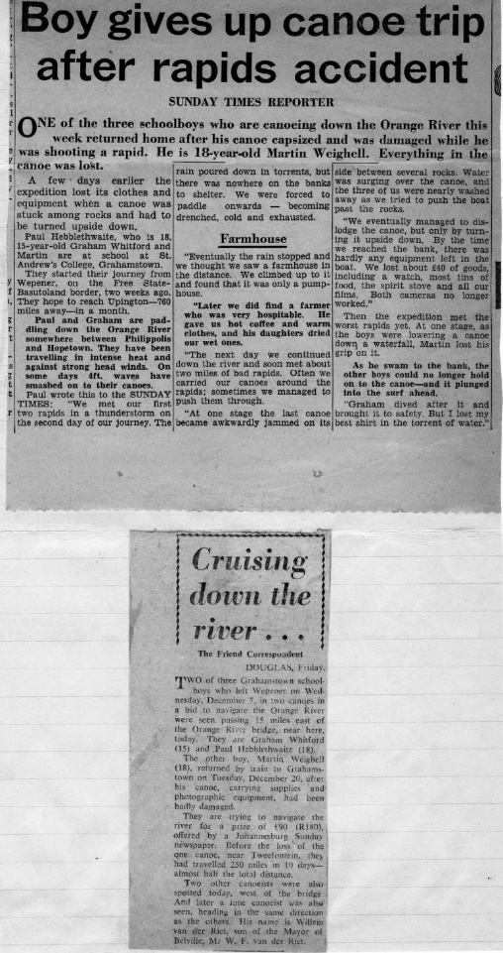

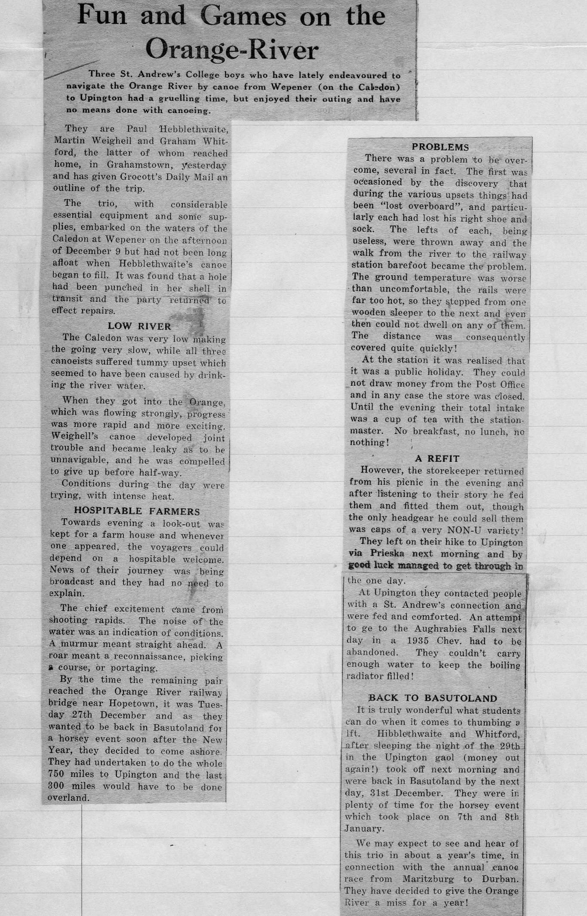

CHAPTER 14B CANOE TRIP DOWN THE CALEDON AND ORANGE RIVER DECEMBER 1960

During 1959 I built a rowing boat in the school workshop and I had then tried to row this down part of the Caledon River. I soon discovered that a rowing boat was most unsuitable for such a venture as you had your back to the direction of travel down the river. Consequently, you were unable to cope with rapids, possible sand banks or rough fast flowing water. I decided to abandon my week-long trip after a few days and was able to persuade a kind farmer to transport me and the boat to the nearest railway station. I managed to sell the rowing boat at auction for a reasonable price before we set sail to the UK.

I then decided to design and build a marine ply canoe in the school woodwork department. I was joined by my two friends Graham Witford and Martin Weighell whom also built canoes using my design. The canoe was broader than most designs and had a fairly flat bottom. I felt this would enable the craft to be more stable and also cope with shallow water and sandbanks. The woodwork teacher was a great help and encouragement and was able to recommend several changes to the design. We included a mechanism that would take a crude sail. My canoe also contained a small water tank with a tap so that we could take on fresh water.

We started to plan a more ambitious trip down part of the Caledon River which eventually joined the Orange River. We had very much hoped to be able to undertake the 700 miles to Upington during the forthcoming summer holidays.

The Headmaster Mr Spencer Chapman also gave us a huge amount of encouragement. He wrote to the manager of the South African Sunday times asking if they would sponsor the venture and he decided to give us £90. However, he requested that we send the newspaper weekly reports of our progress so that these could be included in the paper. We had to send these by express post from Post Offices on route. He arranged for a photographer to take a picture of us by my canoe outside the workshop.

Fortunately, I was able to keep the notes that Martin and I wrote about our adventures soon after we arrived home. My father typed up these notes which has enabled me to write a fairly accurate description of what occurred.

Me with Martin and Graham with my completed canoe 1960

The first Sunday Times article appeared about a week after the above photograph was taken. I have not been able to scan this article as the copy I have has long since disintegrated. However, I have typed out what it contained below.

Their flimsy river craft. Three boys set out to canoe Orange River
SUNDAY TIMES REPORTER

Three adventurous schoolboys will spend Christmas Day canoeing down the Caledon and Orange River. If they, can they hope to celebrate the day with roast duck.

The boys – Paul Hebblethwaite 18, Martin Weighell, 18, and Graham Witford, 15 – are pupils at St Andrew’s College Grahamstown. They left Wepener, in the Free State, at six o’clock this morning on the first lap of their 760-mile journey down the Caledon and Orange River to Upington.

“We are determined to get there even if we have to walk,” said Martin, shortly before they left Grahamstown.

Explorers
Why are they going on this expedition? “Mainly for adventure,” was Martin’s reply. “It is a way of spending our Christmas holidays and we also hope to improve our Geography.”

All of them are members of the school’s Exploration Society. Travelling 10 hours per day, they hope to reach Upington within a month. They may then hitchhike to the Augrabies Falls, 60 miles further on.

Built boats
The boys designed and built their canoes in the school carpentry shop. The boats are 9ft 6inches long and 2ft 6 inches across, and have flat bottoms to make the jumping of rapids easier.

The boys have been spending weeks collecting equipment and information for their expedition. They have a primus stove, wood-chopper, radio for weather reports, and detailed maps of their route. A Grahamstown Chemist has lent them a complete first-aid kit.

Paul is taking 154 dentist injection tubes with him which he hopes to fill with samples of soil and water. Martin, an amateur geologist, wants to collect as many rocks and stones as his canoe can carry.

Between them they have £4 10s and a post office savings book.

Paul and Graham have been on canoe or rowing boat trips before with two other St Andrew’s boys. Paul last year rowed a boat he built from Teyateyaneng, in Basutoland, to Wepener, 176 miles away. Graham has also taken a canoe up the Bushman’s River.

Before I give details of our trip, I give some statistical details relating to the Caledon and Orange Rivers. The Caledon River is called the Mohokare River in Lesotho is a major river located in central South Africa. It has a total length of 399 miles (642 km) and rises in the Drakensberg Mountains on the Lesotho border with South Africa and flows south-westward and then westward before joining the Orange River near Bethulie in the southern Free State.

The Orange River has several names including Gariep River, Groote River and Sengu River. It rises in the Drakensberg mountains in Lesotho at an altitude around 3000 M and flows west to the Atlantic Ocean. It is one of the longest rivers in the continent and one of the longest South of the Tropic of Capricorn. It is also the longest river in South Africa with a total length of 1,367 miles (2,200 Km). While in Lesotho it is called Sengu River and parts of it freeze during cold winters because of the altitude. The total catchment of the Orange River (including the Vaal) extends over 973,000 square kilometres, therefore, about 77 percent of the land area of South Africa. Approximately 366,000 square kilometres (38 percent) is situated in Lesotho, Botswana, and Namibia. The map below shows the Orange River Basin. The second map gives more details of all the rivers with sources mostly in Lesotho all of which feed into the Orange River. It also gives the location of the Caledon River.

Our adventure started at Grahamstown station on the 9th December 1960, we loaded our canoes into the goods section of the South African Railways (SAR) train which stopped at Jammerdrift station near Wepener where we would start our trip in the Caledon River. The guard was reluctant to have them on the train as he maintained that they could be easily damaged. But we somehow managed to persuade him to do so on the understanding that we were prepared to take the risk – what else could we do?

When we arrived at Jammerdrift at 1.45 pm around 1 mile from the river. We helped to unload our canoes. Fortunately, there was a lorry belonging to a flour mill company outside the station and the driver kindly transported our canoes to the river bank. The canoes were offloaded by a couple of Africans and they helped us to get them and our possessions down to the river. At around 4.30 pm we set off on our journey. We felt ambitious, excited and full of energy at this stage. The first thing we noticed was that the Caledon was running very low and there were sandbanks in all directions. After paddling for about 200 yards, I found that my canoe was taking on water. On examination I was able to find a small hole which must have been caused in transit with SAR. I was able to repair the hole using a small piece of ply and using the appropriate fast setting glue. We then paddled on for around 10 miles and decided to set up camp for the night. I managed to cook scrambled eggs and sausages for our meal on the primus stove. During the night we all suffered from the effects of drinking the river water even though we had boiled it. We had not been able to fill my water tank with fresh water at this stage.

On Saturday the 10th we rose at 5 am and after a hasty breakfast of porridge we set off once again. We made slow progress avoiding sandbanks. In the afternoon we were caught by a heavy storm but we battled on for around 15 miles even though we were drenched and cold. After emptying the canoes of all water accumulated from the storm, we were able to walk to a nearby farm. The farmer Oom Piet Hugo, his wife and his two beautiful daughters invited us to stay the night. They lent us some dry clothes and we returned to the river and make sure the canoes were safe. The daughters dried our clothes and then provided us with a very enjoyable supper. We managed to converse with them in Afrikaans but at times they switched to English. We were made very comfortable in their spare room.

The next day (Sunday 11th) we were woken by Oom Piet at 5 am. After a good breakfast Oom Piet gave us plums, milk, eggs, biltong, raisins and helped us patch Martins canoe that had a persistent leak with reservoir cement. The whole family then waved us off. He then contacted another farmer called Oom Hendrik Vander Walt further down river who was waiting for us and provided us with some lovely large peaches. We paddled on and met with our first disaster. While Martin’s canoe was being pushed through powerful rapids it became wedged against a rock and turned on its side. Torrents of water swept clothes, primus stove, coffee, rucksack, pot, pan and colour films into the river. After a desperate struggle the canoe was released by turning it over to get rid of all the water. Fortunately, we were able to retrieve the primus stove and pots and pans. Thoroughly fed up we sat on the bank and consumed a can of bully beef for lunch. We then paddled on hoping to make up some time. Late in the afternoon we were again caught in a violent storm and were soaked to the skin. Fortunately, a kind farmer called Oom Grayling (he had been contacted on the farmers network) put us up for the night. His wife dried out our clothes and provided us with a meal.

On Monday the 12th we rose at 5 am and after a good breakfast provided by Grayling’s wife, we set off at around 6 am. After around 5 miles we came across our first weir which was around 15 ft high. We were forced to carry the canoes round this obstruction which was exhausting. We paddled on through more rapids and Martin again capsized and lost his watch and his camera was wrecked. However, we manged to cover around 30 miles in the extreme heat and by 7 pm we were badly sunburnt (no sun tan cream in the 1960’s) and set up our camp at 6.30 pm. After cooking a meal on an open fire, we felt so exhausted we were in bed by 8.30 pm.

The next day (13th) we were up by 6.30 am and after breakfast at around 7.30 am we set off and made good progress at around 3 miles per hour as there were no rapids but occasional headwinds. By the time we set up our camp at 6.30 pm we were all exhausted as it was exceptionally hot. However, we covered about 40 miles and felt encouraged by our progress.

On the 14th we arose at 6 am after a terrible night and a scanty breakfast we set off at around 8 pm. At 10 am we reached Commissie bridge and I hitched a lift to Smithfield to obtain supplies and write a letter to the Sunday times in relation to our progress thus far. I had an awful lunch in a café and then had to wait another hour for the post office to open. I then sent telegrams to our parents and to the Sunday Times and posted the letter I had written. I had to then walk 3 miles before getting a lift back to the river. On my return I found Graham and Martin asleep on the river bank. Martin had managed to purchase some eggs from a very grumpy farmers wife. We again set off at 4.30 pm and continued down river until 6.30 pm. We walked to a nearby farm and the farmer allowed us to sleep overnight in a dilapidated rondavel. He also gave us a plate of pap and eggs for super. We turned in at 8 pm and all slept well.

On the 15th we arose at 5.30 am and had breakfast by the river. We were able to obtain three bottles of milk and a bucket of fresh water to top up my water tank from the farmer. Before we left at 7.45 am we spent some time taring Martin’s boat to try and stop more leaks. We soon encountered the worst rapids of the whole trip. We struggled for hours and had to carry the craft around 3 waterfalls. At one stage we had to carry our canoes for around a mile and a half. By 5 pm we were exhausted and decided to call it a day but after spotting a farm house about 2 miles ahead we battled on in the hope that a kind farmer would take us in for the night. Unfortunately, we did not spot a 15 ft waterfall ahead. We managed to land on a rock and bring the canoes to safety. Graham and I managed to let our canoes down the drop safely but Martin slipped and fell heavily on his back. His canoe crashed over rocks but fortunately came to rest a few inches from the drop. With a struggle he was then able to lower his canoe successfully. Before we reached the farm house we had to battle through another mile of rapids. The farmer, Oom Piet Schoeman kindly allowed to sleep in his barn and provided us with some food. He informed us that there were some very serious rapids ahead which went on for around 5 miles and suggested that he should transport our canoes around them. We readily agreed.

On the 16th we had a scanty breakfast of pap. Oom Piet Schoeman helped us to load our canoes on his truck and transported us and the canoes round the serious rapids. We drove to Bethulie on a terrible bumpy road for around 45 minutes with Martin and I on the back of the truck. We kept bouncing into the air when he went over a deep rut in the road. On reaching the river at about 9.30 am we unloaded and Oom Piet then took us back to Bethulie and had something to eat and drink in a café. He then returned us to the river and after a hearty farewell from Oom Piet we set off at 11.30 am. We paddled on rapidly and after an hour reached the confluence of the Caledon with the Orange River at Bethulie. We felt excited having reached the main river. We had a good meal in the same cafe in Bethulie. We returned to the river and battled against a force 6 headwind. During the whole day the heat was intense at around 95⁰ F or 35⁰ C. We eventually came across a farmhouse and the farmer and his wife kindly gave us supper and put us up for the night.

On the 17th December we got up and had coffee and breakfast and were on the river at 7 am. We made good progress until another strong headwind started at around 11.30 am which enhanced the effects of the intense heat. We then made slow progress but battled on until lunch time. Over lunch we tried to get one of the cameras that was damaged by being submerged to work but sadly, it was damaged beyond repair. As a result, we were never able to take any photographs of our trip. After lunch due to the headwind, we were only able to cover about half a mile in an hour until around 3.30 pm when the wind was behind us due to the direction of the river. However, at 4.30 pm we were again paddling against the wind that was so strong that it produced large waves. After around an hour we only managed to progress around half a mile and were exhausted. At around 7.30 pm we dragged the canoes to a safe place and set off to try and find a farm. We walked along the bank and inland but were unable to locate a farm and, on our way, back we got lost in the dark. Fortunately, we came across an old abandoned house and thankfully, settled there for the night. One of Martin’s feet was so badly sunburnt that he was unable to remove his sock.

On the 18th we rose at 5.30 am walked back to the river and had breakfast and set off at 7.30 am. With a slight wind behind us we made reasonable progress. At 10.30 am we came across some difficult rapids but managed to navigate through them without mishaps. We continued on with the wind behind us. It was extremely hot at 101⁰ F or 38⁰ C registering on my thermometer. At 12.30 pm we managed to purchase some milk at a farmhouse and also get some water to top up my tank. After lunch we again came across terrible rapids and Martin’s canoe was smashed on rocks and capsized and his foot was badly bruised by the weight of the canoe on his foot. He lost most of his equipment as well. What made it worse was that Martin also damaged my paddle by traying to push away from a rock. I had lent him my paddle as it was curved at the ends and was easier to use and more efficient. We struggled on for around another hour until we came across a farmhouse where the farmer helped us to try and repair his canoe using pitch. They invited us to stay and his sons took us around the farm and showed us their 3-story pump house used pumped water from the river to irrigate their crops. I found al this most interesting as I already was thinking about a career in Agriculture. As it was a Sunday, we had a church supper in the Dutch style. In the evening we were able to fix my paddle with glue. We turned in at 8.30 am as we were exhausted.

On Monday the 19th we got up at 6 am and were back on the river at 8.30 am. We made good progress for 10 miles and then were again caught in a storm and got drenched. Martin’s canoe kept taking on water due to the damage and he reluctantly decided to abandon the rest of the trip and return home by train. Fortunately, we were able to leave our canoes on the bank and walk back to the farm where we stayed the previous night. One of the farmer’s sons loaded Martin’s canoe onto their Lucerne lorry and kindly took him to Donkerpoort which was the nearest station where he was able to catch a train back to Grahamstown. We had mixed feelings about his departure as we had enjoyed his sense of humour and his contributions keeping a log of our progress. However, he was struggling and at times he could not keep up and was left far behind which delayed our progress. We then stayed another night with the farmer and his family.

On the 20th we rose at 4.39 am had coffee and walked back to our canoes. After bailing out the water we set off at 7 am and covered about 5 miles and then stopped and had breakfast. We then battled on against the head winds and many dangerous rapids. On one occasion Graham was completely submerged shooting a rapid but came up eventually the right way up much to his amusement. I started to suffer with a lot of back pain which made me wonder whether I could continue. We arrived at Norval’s Pont at 11.30 am feeling a little fed up, tired and hungry. This adventure was turning out more difficult than we had anticipated. We telegraphed our anxious parents at the post office in Norval’s Pont and then bought more supplies. A local farmer, Mr Holland, gave us lunch and a bed for the night. His wife kindly repaired my torn cockpit canvas.

On the 21st we got up at 4.30 am and had breakfast but unfortunately Graham was so sick that he could not continue, so Mr Holland’s son Tom accompanied me as far as Colesberg Bridge around 20 miles on in Graham’s canoe. Tom brought his gun and was able to shoot a couple of ducks and some dassies. At 10.30 am we came across a waterfall and had to carry the canoes round it. We were also paddling into headwinds which slowed our progress. At 11.30 we met another water fall just before entering a gorge and were forced to carry the canoes around it. We eventually arrived at Colesberg Bridge where Mr Holland and Graham (much recovered) meet up with us. After hearty farewells to the Hollands, we continued our journey. From there Graham and I came across 2 large waterfalls which we had to carry round. Later in the day headwinds raged and we averaged about half a mile per hour. Mr Holland had contacted the next farmer called Mr Venter and eventually we arrived and his family kindly put us up for the night and provided us with a good evening meal. It amazed both of us how kind and hospitable all these farmers and their families were. Nothing seemed too much trouble to them.

On the 22nd we were up at 5.30 am and back on the water at 6.15 am. We made good progress and stopped at 7.15 am to have breakfast. We then left at 8 am and passed through a 12-mile gorge with steep rocky sides. We did not have to do much paddling as the rapid flowing river enabled us to move at an astonishing speed. However, we did struggle with extremely powerful whirlpools which on occasions turned us right round. As the river was forced through this narrow gorge, we estimated that we were moving at about 12 miles per hour. We met numerous rapids and waves and had to bail out our canoes every time we jumped the more serious ones. We were able to spot some lovely spring buck which were owned by a local farmer and he was on the bank to wave us in. Obviously, another Mr Holland contacts. The family provided us with a good lunch and showed great interest in our adventure. We left the farm at 2.30 pm and again battled through rapids and this resulted in us having to carry the canoes for around 50 yards to get round the worst ones. We came across two other canoeists in their fibre glass canoes and we all set up camp together at 5.30 pm. They were brothers called Van Riet. We enjoyed a meal together before we all went to bed at around 8 pm as we all planned to make a very early start. The Van Riet’s were amazed that we had built our own canoes but they felt that marine ply canoes were not really suitable for the rapids as they were likely to be easily damaged and of course they were quite right. Their canoes were also very light and they were able to empty the contents then carry them on their shoulders and then return for their kit and supplies.

On Friday the 23rd December we were all up at 5.30 am and on the river at 6.15 am. We stopped for breakfast but the Van Riet’s continued their journey after we had exchanged addresses. After a hasty breakfast we continued and came across numerous rapids but the canoes fared well even though we took on a lot of water and had to frequently stop and bail out. We reached Havengaburg Bridge at about 5.30 pm after covering 48 miles which was our record daily distance. We stayed the night with a very wealthy farmer (another Mr Holland contact) and his beautiful 16-year-old daughter with long blond hair. I have always been attracted to blonds! We were not sure where his wife was but did not think it was right to ask.

On Saturday the 24th we were up at 5 am and given sandwiches for breakfast and a large packet of peaches. We stopped briefly for breakfast at 7 am after rapidly covering 7 miles as there were no rapids. We were soon back on the river and at around 10.30 am we reached what we thought was a serious stretch of rapids. We were able to beach our canoes some distance away and walk along the back intending to survey the rapids. Unfortunately, a large tree blocked our way and we were not able to do so. We were too tired to bother trying to break through the branches and returned assuming the rapids were navigable. Graham set off first with me close behind. Suddenly we came across a waterfall of around 10 feet ahead of us. The current was so strong that we had no option but to go over it. We both capsized at the bottom of the fall. Graham was caught under his canoe and had to push himself out only to be sucked under by the drop wave. I was thrown out while the canoe turned over and also sucked under by the drop wave. When I came up, I was hit by another large wave and again submerged. Graham managed to grab his overturned canoe. While I was underwater, I manage to drab the rope attached to my canoe. I pulled myself to the craft. Graham managed to get to land but me and my canoe plus paddle were washed downstream. Graham ran along the bank in pursuit. When he had caught up with me, he took a headlong plunge into the river and helped me bring my canoe to safety about 250 yards downstream from the waterfall. Fortunately, losses were small but we lost our snake bite serum, a mug, plate and pot lid. We were later informed that the waterfall was actually 12 feet high. By 11.30 am the canoes were completely bailed out and at 12 pm we had lunch and then had a 2-hour sleep as it was very hot and we also needed to dry out our clothes. We then walked to a farm to see if we could get some dry matches and Mr Bluemen the farmer kindly asked us if we would like to stay with him and his family for Christmas and we gratefully, accepted his offer. We then returned to the river to make our canoes safe and collected our wet clothes etc. While we were there Van Riet arrived and informed us that his brother’s canoe had been lost at the waterfall and he was going on by himself. It made us feel lucky that we still had our canoes intact and functional.

On the 25th we had a wonderful Christmas with Mr Bluemen, his wife and two children. His farm was in an exceptionally dry area and they had not had any rain for over 4 years. We witnessed his African cowman drink 3 mugs of vodka, 2 mugs of wine, 1 mug of brandy and 2 mugs of peppermint liquor then walk home and at 6 pm arrive back to milk the cows! On Christmas day we were served a wonderful roast chicken dinner by his wife which was mostly cooked by their African cook.

On Monday the 26th we left at 6.30 am and paddled for 2 hours and stopped for breakfast. Van Riet came by and stopped for breakfast with us. We were back on the river by 9.30 am and at around 2.30 pm my canoe was turned over in a whirl pool and I lost my school ruck-sack, my hat and one of my shoes. We were both feeling very fed up and decided that we would try and continue on to reach Prieska in the Kalahari Desert and then call it a day. We made good progress for the next few hours and reached Orange River Bridge at 3.30 pm. We walked around 2 miles along the railway track jumping from one sleeper to the next as the ground was so hot. The temperature was about 105⁰ F or 41⁰ C We waited the rest of the day at Orange River Station for the shop keeper to open his shop so that we could purchase hats and shoes. Apparently, he and his family had gone off for a picnic. He eventually turned up and we were able to purchase caps and shoes. Unfortunately, he did not have hats so the caps were the only option even though they looked awful and we looked decidedly funny wearing them. Below is a photograph of us wearing the caps which my father took when we arrived home. The shop keeper (Mr Van Rensburg) was fascinated hearing about our adventure thus far and he and his wife asked us if we would like to stay the night and tell them more about it and we readily agreed. The kindness and hospitality of strangers was the major reason we were able to get thus far. Everyone we met were so kind.

On Tuesday the 27th we were up at 5 am and Mr Van Rensburg drove us to the river and waved us farewell. He had also supplied us with various items of food without charge. Unfortunately, I have no records of the journey to Prieska on the river as my logbook did not contain anything. Sadly, I am unable to remember why. Possibly, I had decided that I had enough of logging our journey or possibly Graham had taken over and then never let me have his notes. I may have even lost these notes or they were destroyed by getting wet.

We arrived in Prieska via Hopetown on the 2nd January 1961.The town lay on the south bank of the river in the Northern Cape. I vaguely remember us spending New Year’s Day on a farm some miles from Prieska with an English farmer. In Prieska we were able to spend the night with another store keeper and he kindly agreed to rail our canoes back to Grahamstown which was exceptionally helpful. He also collected the canoes from the river in his truck. We were able to draw some money from the post office to pay him for the cost. We had by then realised that it would be impossible to get all the way to Upington on the river. We were rapidly running out of money and finding it difficult to keep going. We had covered about 450 miles and we felt that was quite an achievement. We therefore decided to hitch a lift to Upington so that we could eventually visit the famous Augrabies Falls.
Augrabies Falls are the major waterfall of the Orange River. The falls are commonly cited as being 480 feet tall, but this appears to be a figure quoting the change in elevation from the top to the bottom of the canyon. The main part of the falls in actuality stands about 183 feet tall. In full flood, the Orange River fills the canyon below the falls and in many places almost 500 feet deep - nearly to the brink, and in truly epic events, the falls themselves can be almost submerged. It has been estimated that 95% of the flow of the Orange River goes over the falls in low water. During floods around 80% goes over the falls. The remaining water forms 19 minor falls, most of which exceed the main fall in height. The name Augrabies comes from Aukoerebies, a Khoi name meaning, the place of the great noise.
The falls are certainly among the major large-river waterfalls in the world, so notable in fact that Edward Rashleigh wrote extensively of the falls in his 1935 book Among the Waterfalls of the World. However, despite the factors making this such a great waterfall, because the volume of the Orange River varies so greatly between the wet season and the rest of the year, and ultimately because it’s so hard to appreciate the falls from the ground, Augrabies Falls can't be considered more than a second-tier world class waterfall.

I have included some statistics in relation to these falls below.

Total height 183ft or 56m
Tallest drop 183ft or 56m
Number of drops 1
Average width 80ft or 24m
Maximum width 2,300ft or 701m
Pitch 75 degrees
Run 200ft or 61m
Form Sliding punchbowl
Watershed Orange River
Average high volume 11,050 cfs or 313 cms
Average low volume 0 cfs or 0 cms
Source Lesotho South Africa border in Drakensberg mountains

Graham Whitford and I wearing our terrible flat caps in 1960

On the 3rd January 1961 we started walking from Prieska along the road to Upington carrying around 40 lbs on our backs hoping to hitch a lift. We walked about 15 miles in blazing sun before we were able to thumb a lift on the back of a lorry all the way to Upington. We arrived in Upington at 7 pm and located Mr Holmes a local garage owner who was an Old Adriane. He had been contacted by our headmaster Spencer Chapman whom had asked him to look after us if we turned up in Upington. The family provided us with a good meal and then dropped us off at the best hotel in the town where we were able to have a bath and spend a comfortable night in a bed. He even paid the bill in advance! The kindness of strangers never seizes to amaze me. We must have looked quite a site in our shabby and rather dirty clothes and I had grown quite a sizeable beard.

Upington was founded in 1873 and is located in the Northern Cape province and lies on the banks of the Orange River in the Kalahari Desert. It is the principal town and commercial, educational and social centre of the green Kalahari due to its agriculture which exist due to irrigation from the Orange River. However, its economy owes a lot of its prosperity to tourism due to the flowers of Namaqualand and the Augrabies National Park.

On the 4th January we were up and breakfasted by 8 am and then went to the post office to send telegrams to our parents and a letter to the Sunday Times. We then called in at Holmes Garage and Mr Holmes very kindly loaned us a real vintage model Chevrolet so that we could drive to the Augrabies Falls. His mechanic warned us that the radiator was leaking slightly and he provided us with a large can of water so that we could top it up when needed. He also warned us that the river was in spate and we should be careful when viewing the falls. Unfortunately, after around 15 miles we realised that the Chevrolet’s radiator was boiling. We toped it up and then had to repeat every 3 miles in order to stop it boiling. We were rapidly running out of water and had to stop at windmills to top up our water supply. The ground was red and very dry with scrub bushes scattered about. Stones of intense colour and beauty could be seen everywhere. Eventually, we arrived in at Keimeos about 27miles from Upington and the garage mechanic there advised us to return to Upington as he was unable to repair the radiator. He topped up our can of water to help us on our return journey. Consequently, we were never able to see the falls which was a huge disappointment.
We then decided to take his advice and set off back to Upington. We returned the car and explained about the problem and Mr Holmes apologised but said he had not realised the leak was so bad. Unfortunately, he did not offer to repeat his previous generosity to put us up in the hotel. We had very little cash left and needed what remained to eventually purchase train tickets home to Basutoland. We therefore had to spend the night in the local jail which the police officer reluctantly allowed us to do.

The next morning, we drew £5 from the post office and in doing so we missed a lift that had been offered to us by a friend of one of the police officers. This lift would have taken us around 300 miles through the desert from Upington. We managed to hitch several lifts and by the end of the day reached Groblershoop around 73 miles from Upington. I had developed a touch of sunstroke in the intense heat and lost the skin off my nose. At one stage we sat by the road for over an hour in the intense heat, as there was no shade, before we obtained a lift. During the whole day we only had a tin of pineapples to eat. Fortunately, we were invited to stay the night by a garage owner who knew Mr Holmes. Groblershoop was an interesting place and was situated around a mile west of the orange river. The garage owner told us that it was founded in 1914 on a farm called Sternham, but was renamed in 1939 after Piet Grobler, a former Minister of Agriculture. Apparently, the region became considerably more developed in 1929 after the construction of the Boegoeberg Dam and water channels. It is now known as the gateway to the Green Kalahari as the region is a major wine-producing area. It is also producer of large table grapes and sultanas.

On the 6th January we waited 2 hours by the road before obtaining a lift 25 miles on to Bleiberg. We waited there around 3 hours before we obtained a lift of around 300 miles to Noupoort a small town in the eastern Cape. We arrived at 10.30 Pm and it was bitterly cold so we decided to catch a train via Bloemfontein to try and get to my then home in Mohales Hoek in Basutoland.

On the 7th January we arrived in Bloemfontein at 9.30 am and changed train to Gumtree and arrived there at 1.30 pm. We then caught an African bus to Mohales Hoek and arrived there at 2.45 pm feeling exhausted but pleased we were finally home. Mum and Dad were pleased to see us and highly relieved we had not been murdered or bitten by a snake.

During our whole adventure we had travelled about 1600 miles in intense heat by day with cold nights. I can say that we both enjoyed the experience in spite of the hardships. We improved our Afrikaans from the farmer friends we made and improved our knowledge of geography, but we felt that for our next trip we would favour the cold wastes of the Antarctic in preference to the oven-like conditions of the Kalahari where temperatures could reach 115⁰ F or 46⁰ C. In hindsight it would have been better for us to have started our trip on the Orange River itself at the confluence of the Caledon with the Orange River at Bethulie rather than on the Caledon at Jammerdrift.

Some of the reports by the Sunday Times Reporter were not totally accurate but I have included them below. Unfortunately, copies of some of the articles have been sadly lost over time. Which is not surprising as I am writing this chapter 62 years after this adventure.

